Science

Policy

Holy Trinity CE Academy
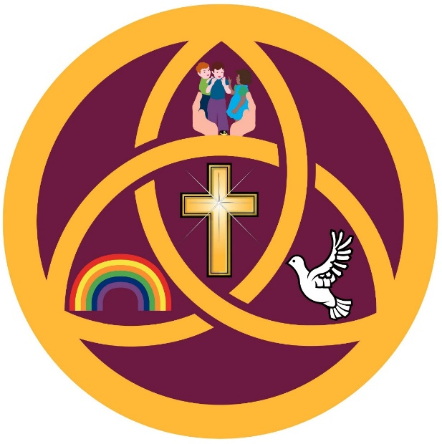

At Holy Trinity CE Academy, we believe science provides pupils with the knowledge, skills and curiosity needed to understand the world around them. Through our Christian values of Love, Joy and Respect, we aim to inspire children to become inquisitive learners who ask questions, explore ideas and develop a lifelong interest in science.
Our science curriculum promotes a sense of wonder and responsibility towards the natural world while equipping pupils with the substantive knowledge and disciplinary skills needed for future learning and everyday life.
This policy outlines the intent, implementation and impact of science teaching and learning at Holy Trinity CE Academy.

Aims of the Science Curriculum
At Holy Trinity CE Academy, we aim for all pupils to:
- Develop secure scientific knowledge across biology, chemistry and physics.
- Build understanding through a progressive and carefully sequenced curriculum.
- Develop confidence in working scientifically through practical enquiry and investigation.
- Ask questions, make predictions and explain ideas using scientific vocabulary.
- Recognise the importance of science in everyday life and the wider world.
- Develop resilience, curiosity and independence when exploring scientific concepts.
- Appreciate and care for God’s world through responsible and respectful attitudes towards the environment and living things.
- Be prepared for the next stage of their education and future careers.

Our Science Curriculum
Our science curriculum is designed to inspire curiosity, foster a sense of wonder, and develop pupils’ understanding of the world through a systematic and progressive approach to scientific knowledge and enquiry.
We aim for all pupils to:
- Develop secure substantive knowledge across biology, chemistry and physics.
- Build a deep understanding of key scientific concepts through a spiral curriculum that revisits and builds upon prior learning.
- Become confident in working scientifically, developing skills in observing, questioning, predicting, investigating, recording and evaluating.
- Understand the relevance of science in everyday life and its impact on the wider world, including sustainability, health, technology and future careers.
- Use accurate scientific vocabulary to explain ideas clearly and confidently.
Rooted in Love, Joy and Respect, our curriculum encourages pupils to value the natural world, show joy in discovery and exploration, and demonstrate respect for evidence, ideas, living things and one another’s thinking.
Our curriculum is ambitious and inclusive, ensuring that all pupils, including those with Special Educational Needs and/or Disabilities (SEND), are supported to access the full breadth of the science curriculum and achieve well.

Teaching and Learning in Science
Science is taught through a carefully sequenced, progressive curriculum based on the National Curriculum and supported through the use of Kapow Primary’s scheme of work.
The curriculum is organised into key scientific strands including:
- Plants
- Animals including humans
- Living things and their habitats
- Materials
- Forces and magnets
- Sound
- Light
- Electricity
- Earth and space
- Seasonal changes
- Evolution and inheritance
Teaching is structured around three core strands:
- Scientific knowledge and understanding
- Working scientifically (disciplinary skills)
- Science in action (real-world application)

Key Features of Implementation
- A spiral curriculum revisits concepts over time, deepening understanding and increasing complexity.
- Scientific vocabulary is explicitly taught and revisited regularly.
- Retrieval practice is used to strengthen long-term memory.
- Practical investigations and enquiry-based learning are embedded throughout the curriculum.
- Lessons provide opportunities for questioning, discussion, prediction and evaluation.
- Cross-curricular links are identified where meaningful and relevant.
- Real-world contexts and diverse scientists are included to raise aspiration and engagement.

Working Scientifically
Pupils are taught to work scientifically through:
- Asking questions
- Making observations
- Conducting fair tests
- Identifying and classifying
- Using secondary sources
- Gathering and recording data
- Drawing conclusions from evidence
- Evaluating investigations
These skills are developed progressively across all year groups.

Inclusion and SEND
At Holy Trinity CE Academy, we believe all pupils are entitled to access a broad, balanced and ambitious science curriculum.
Teachers use adaptive teaching strategies to ensure all pupils can achieve success.
Adaptive teaching is embedded throughout science lessons to ensure all pupils are supported and challenged appropriately.
Strategies may include:
- Scaffolding tasks and instructions
- Modelling scientific processes and vocabulary
- Chunking learning into manageable steps
- Using visual aids and practical resources
- Pre-teaching and revisiting key vocabulary
- Adult support during practical investigations
- Flexible grouping
- Additional challenge for pupils working at greater depth
Pupils with SEND are supported to participate fully in scientific enquiry and practical activities. Teachers work closely with the SENDCo to ensure provision is tailored appropriately to individual needs and EHC plan targets where applicable.
Success is measured from pupils’ individual starting points and all pupils are encouraged to develop confidence, resilience and independence in science.

Teaching and Learning
Science lessons at Holy Trinity CE Academy are designed to be engaging, practical and knowledge-rich.
Teachers:
- Use adaptive teaching strategies to respond to the varying needs of pupils within the classroom.
- Clearly model scientific thinking and vocabulary.
- Encourage pupils to ask questions and explore ideas.
- Use assessment for learning to identify misconceptions.
- Provide opportunities for collaborative and independent learning.
- Ensure practical activities have clear scientific purpose.
- Promote discussion and reasoning.
- Support pupils to record findings appropriately for their age and stage.
Vocabulary is a key priority and pupils are encouraged to communicate using accurate scientific language.

Assessment
Assessment is ongoing and informs future teaching.

Formative Assessment
Teachers assess pupils through:
- Questioning
- Discussion
- Observation
- Practical work
- Retrieval activities
- Marking and feedback
- Pupil explanations and outcomes

Summative Assessment
Teachers may use:
- End-of-unit assessments
- Knowledge quizzes
- Vocabulary checks
- Moderation activities
- Teacher assessment against National Curriculum expectations
Assessment information is used to identify gaps in learning and support progression.

Outcomes for Pupils
By the end of each key stage, pupils at Holy Trinity CE Academy demonstrate secure and connected scientific knowledge across all areas of the curriculum.
Pupils:
- Retain key scientific knowledge and apply it confidently in a range of contexts.
- Use appropriate scientific vocabulary to explain concepts clearly and accurately.
- Demonstrate strong working scientifically skills.
- Show curiosity and enthusiasm for science.
- Understand how science relates to everyday life and the wider world.
- Are prepared for the next stage of their education.
Guided by Love, Joy and Respect, pupils develop responsibility towards the natural world, take joy in scientific discovery and show respect for evidence, living things and differing viewpoints.
For pupils with SEND, progress is demonstrated through personalised outcomes and increasing confidence and independence.
Impact is monitored through:
- Pupil voice
- Book scrutiny
- Lesson visits
- Assessment outcomes
- Planning scrutiny
- Monitoring of curriculum coverage and progression

Equal Opportunities
Science teaching at Holy Trinity CE Academy promotes equality of opportunity for all pupils regardless of gender, ethnicity, religion, disability or background.
Teaching materials and curriculum content reflect diversity and challenge stereotypes. Pupils are introduced to a range of scientists from different backgrounds and cultures.
All pupils are encouraged to participate fully and achieve success in science.

Spiritual, Moral, Social and Cultural Development
Science contributes to pupils’ SMSC development by:
- Encouraging curiosity and wonder about the natural world.
- Promoting responsibility towards the environment.
- Supporting respectful discussion and collaboration.
- Exploring ethical issues linked to science and society.
- Developing appreciation of scientific achievement across cultures and history.
Through our Christian ethos, pupils are encouraged to value and care for creation.

Health and Safety
Teachers ensure that all practical science activities are carried out safely.
Risk assessments are completed where appropriate and staff follow school health and safety procedures alongside CLEAPSS guidance.
Pupils are taught how to use equipment safely and responsibly.

Role of the Subject Leader
The science subject leader is responsible for:
- Monitoring the quality of teaching and learning in science.
- Supporting staff with planning and subject knowledge.
- Monitoring curriculum progression and coverage.
- Managing science resources.
- Leading professional development.
- Reviewing assessment information.
- Supporting school improvement priorities.
- Ensuring the policy is implemented consistently.

Monitoring and Review
This policy will be reviewed regularly by the science subject leader and senior leadership team to ensure it reflects current practice, curriculum developments and statutory requirements.

Policy Review Information
Policy | Science Policy
School | Holy Trinity CE Academy
Reviewed by | Science Subject Leader B.Alldridge
Review Frequency | Annually
Next Review Date | __________________

