PE

Long term plan

Holy Trinity CE Academy
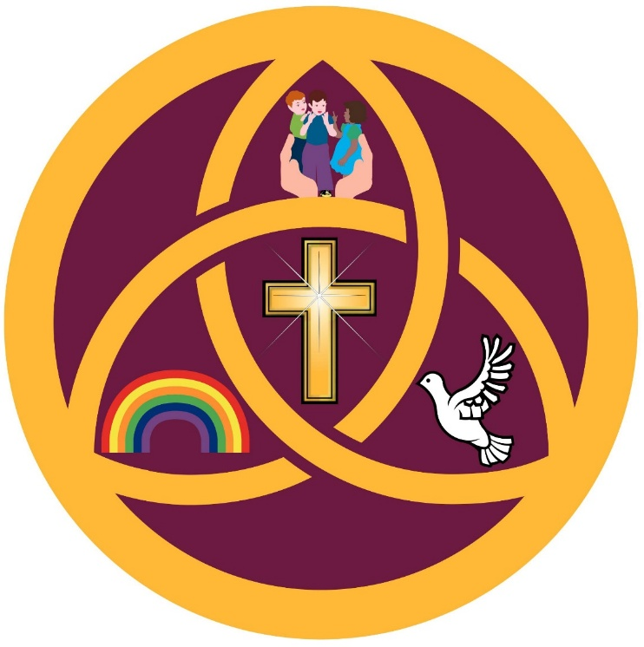

PE

Annual Curriculum Coverage

Reception
Term | Unit | Approximate Weeks
Autumn 1 | Foundational OAA Skills + Fundamental Movement | 3 + 4
Autumn 2 | Dance and Gymnastics | 7
Spring 1 | Ball Skills / Net and Wall Foundations | 6
Spring 2 | Invasion Games Foundations | 6
Summer 1 | Striking and Fielding Foundations | 6
Summer 2 | Athletics | 6

Key Stage 1 (Years 1–2)
Term | Unit | Approximate Weeks
Autumn 1 | Foundational OAA Skills + Invasion Games | 3 + 4
Autumn 2 | Dance and Gymnastics | 7
Spring 1 | Net and Wall Games | 6
Spring 2 | Invasion Games | 6
Summer 1 | Striking and Fielding Games | 6
Summer 2 | Athletics | 6

Key Stage 2 (Years 3–6)
Term | Unit | Approximate Weeks
Autumn 1 | Outdoor Adventurous Activities + Invasion Games | 3 + 4
Autumn 2 | Dance and Gymnastics | 7
Spring 1 | Net and Wall Games | 6
Spring 2 | Invasion Games | 6
Summer 1 | Striking and Fielding Games | 6
Summer 2 | Athletics | 6

Swimming
Year 5 pupils receive additional swimming instruction throughout the academic year alongside the core PE curriculum.
Pupils are taught to:
- swim competently, confidently and proficiently over a distance of at least 25 metres
- use a range of strokes effectively
- perform safe self-rescue in different water-based situations

