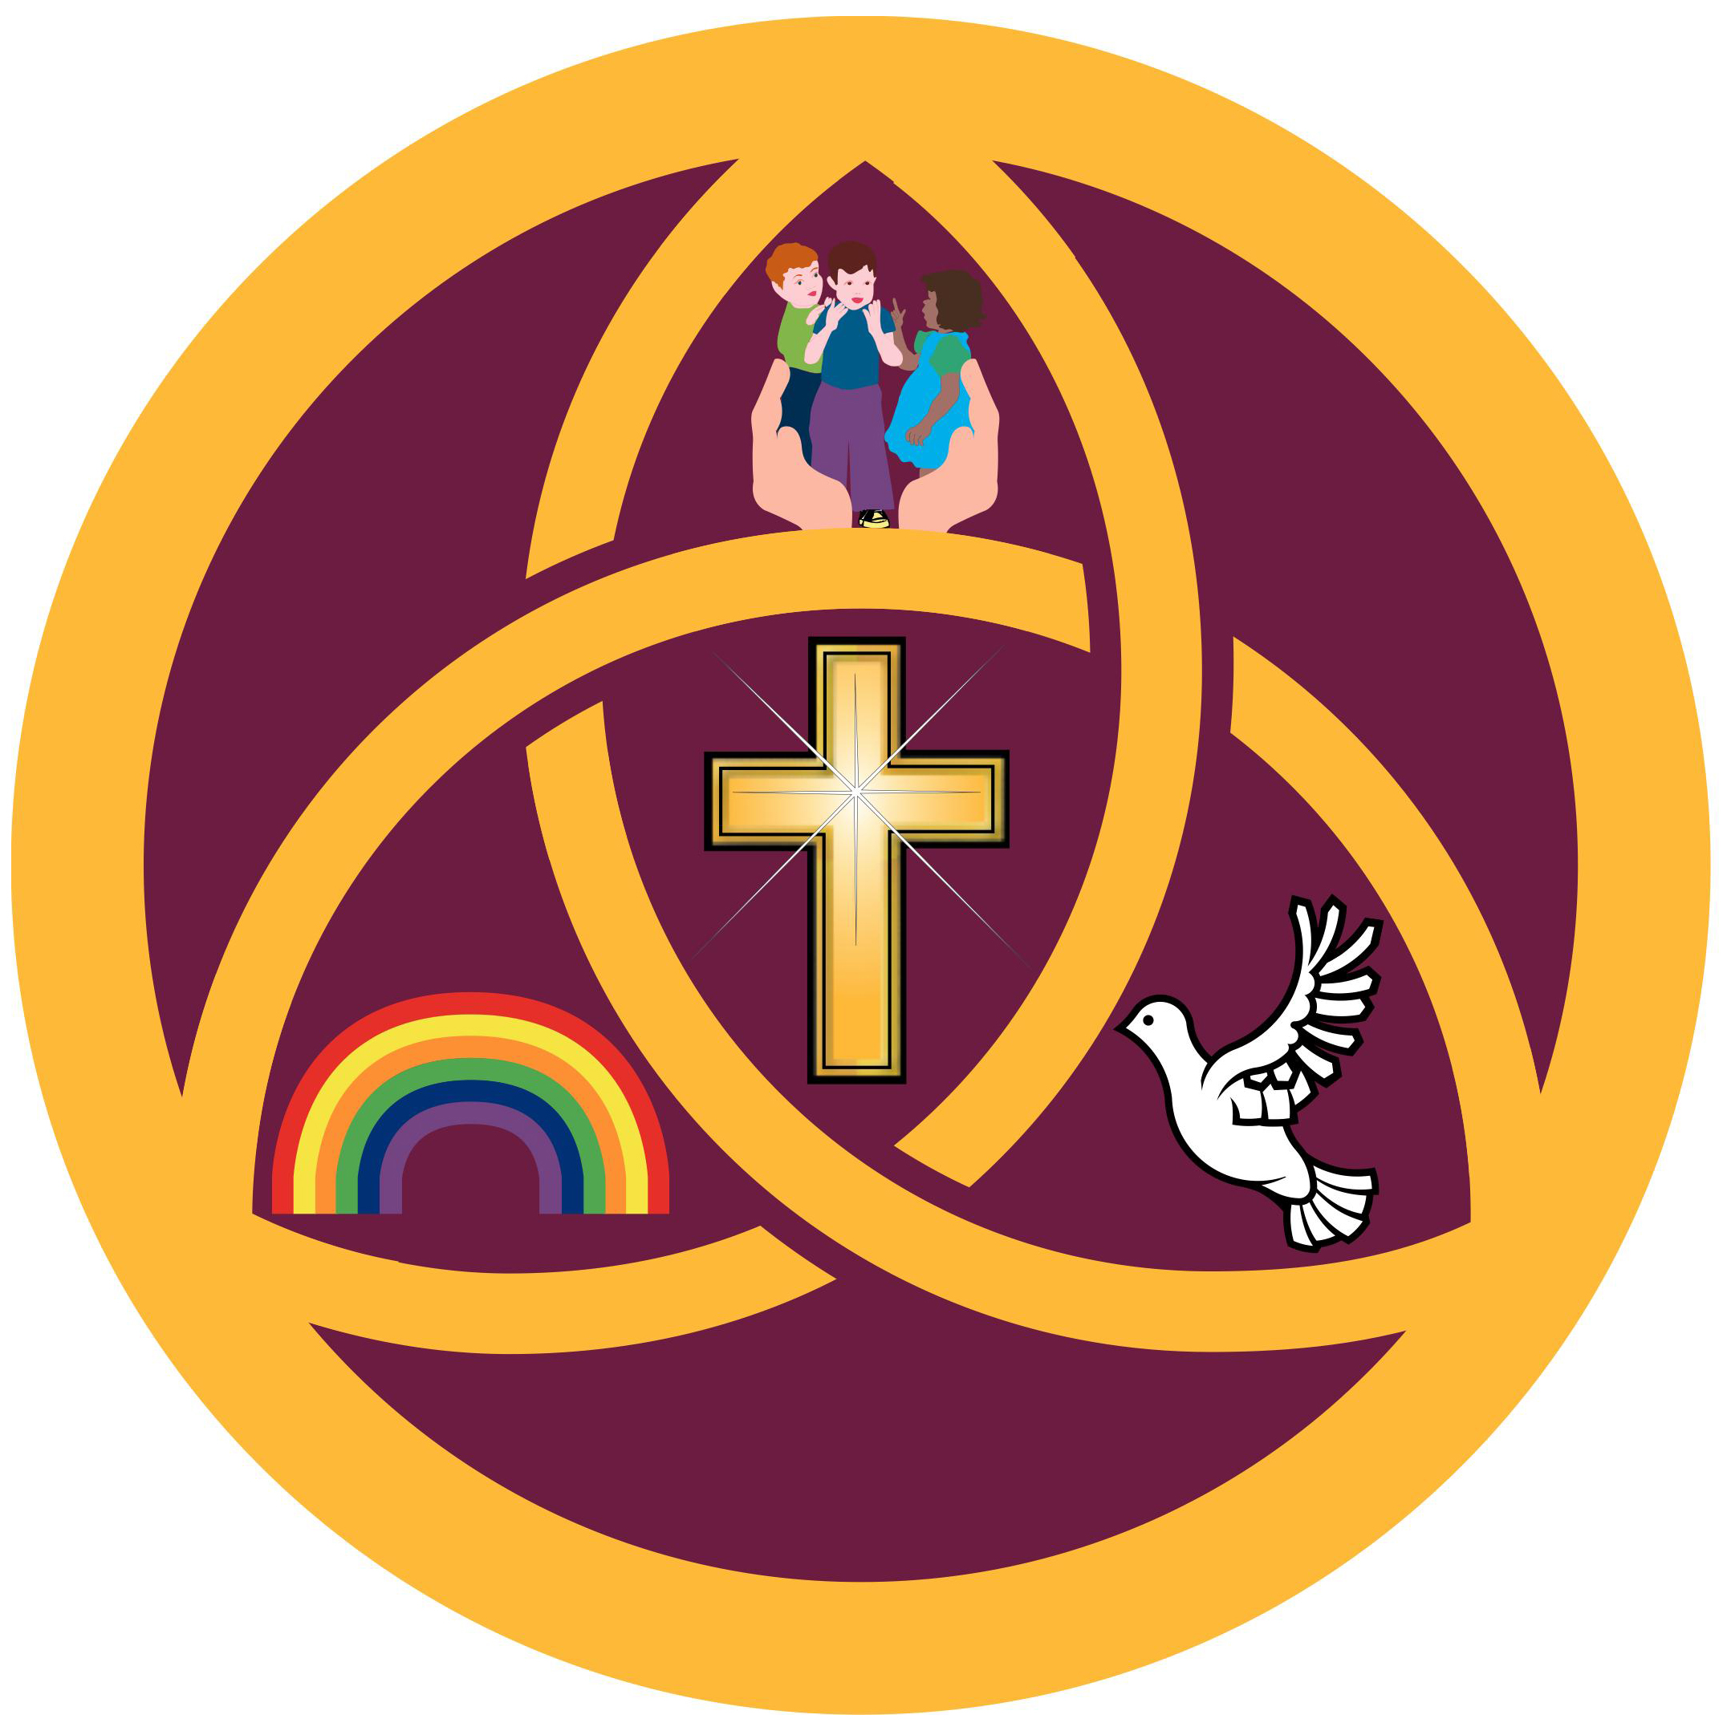

HOLY TRINITY
Church of England Academy

“Let the children come to me and do not stop them. Because the Kingdom of Heaven belongs to such as these.”
Matthew 19:14

Introduction:
This is a statement of the aims for the development of Spiritual, Moral, Social and Cultural education.

In Holy Trinity CE Academy spiritual, moral, social, and cultural development will be promoted not only through all the subjects of the curriculum but also through the ethos of the school, collective worship and also through the teaching of Religious Education. It will be re-inforced through the modelling and demonstration of Christian Values which are inherent throughout the school.

Rationale:
The Education Reform Act (1988) requires the curriculum of a maintained school to ‘promote the spiritual, moral, cultural, mental and physical development of pupils at the school:
- Provision for SMSC development will be inspected by both OFSTED and Section 48 inspectors.
- All maintained schools-including church schools – must provide a daily act of Collective Worship for all registered pupils.
- The connection between good results in the curriculum and high standards in SMSC development is widely acknowledged and is evident in a significant number of OFSTED reports.
- The SMSC aspects of education concentrate on the development of the pupil as an individual and as a personality, aiming to enrich and extend the human existence of each child in relation to the values, attitudes, beliefs and consequent behaviour acquired during school years.

Definitions:
Spiritual development is concerned with exploring dimensions of human experience which helps pupils consider their thoughts, feelings and relationships more deeply and, in particular, to consider those things which are of special significance, such as people, places, objects and stories. It is to do with the search for meaning and purpose in life and for values by which we live. All areas of the curriculum may contribute to pupils’ spiritual development.

Moral development is concerned with pupils’ ability to make judgements about how they should behave and act and the reasons for such behaviour. It refers to their knowledge, understanding, values and attitudes in relation to what is right or wrong.
The system of rules and codes of behaviour established in our school is an important early introduction to issues of fairness for all and to the consequences of operating outside the acceptance rule system. Pupils are encouraged to understand the need for a common code and to follow it from conviction rather than because of consequences or sanctions. Moral development based on Christian principles, should enable pupils to become increasingly responsible for their own actions and behaviour.

Social development refers to the development of abilities and qualities that students need to acquire if they are to play a full and active part in society. It also relates to the growth of knowledge and understanding of society in all its aspects.
The school, but in particular the classroom, provides a suitable environment for promoting social development within a Christian context. Pupils learn to lead, to use their initiative and to use individual skills and strengths when working together towards a common goal. The ability to be led to support others and to recognise the different skills of other group members can be developed when children work co-operatively.

Cultural development refers to the development of knowledge and understanding of differing cultural beliefs, customs and traditions. It is an increasing appreciation of the systems of values and attitudes which form the basis of identity and cohesion within societies and groups.

Aims for Spiritual Development:
- The ability to listen and be still
- The ability to sense the sacred, the holy, the divine
- The ability to sense wonder and mystery in the world.
- The ability to sense the special nature of human relationships
- The ability to transcend the mundane
- The ability to reflect

Objectives for Spiritual Development:
- To develop the skill of being mentally still, concentrating on the present moment.
- To promote an awareness of and enjoyment in using ones imaginative and creative potential - making the most of all enriching experiences
- To encourage quiet reflection during a lesson or act of worship.
- To understand and respect differences between people and their beliefs and religions
- To encourage thought and reflection on own personalities and inner sense of what we value
- To be able to express own feelings and be aware of and empathise with other people’s feelings
- To recognise and understand negative emotions and control those emotions
- To consider the awe and wonder of our world
- To value all contributions

Aims for Moral Development:
- To understand the principles lying behind decisions and actions
- To be able to take moral decisions for themselves
- To assume moral responsibility through belief and conviction.
- To be able to distinguish between right and wrong.

Objectives for Moral Development:
- To develop sense of right and wrong
- To understand fairness and injustice
- To consistently promote behaviour that is right rather than wrong
- To be aware of behaviour acceptable in society and that lack of retaliation is not a weakness
- To respect the rights and property of others.
- To act considerately towards others and treat people the way we would like to be treated
- To modify reactions to other people especially to incitement from others .
- To understand reasons for behaviour in particular situations
- To control own actions and behaviour
- To take responsibility for one’s own actions
- To exercise self-discipline.
- To be honest and truthful
- To consider consequences of actions and effect on others.
- To develop positive attitudes and relationships
- To understand need for rules and necessity to conform to rules and regulations for the good of all
- To develop standards and a moral code for life
- To consider moral dilemmas and develop skills and attitudes to make moral decisions

Aims for Social Development:
- To relate positively to others.
- To participate fully and take responsibility in the classroom and in the school.
- To use appropriate behaviour, according to situations.
- To engage successfully in partnership with others.
- To exercise personal responsibility and initiative.
- To understand that, as individuals, we depend on family, school and society.

Objectives for Social Development:
- To understand different kinds of behaviour in society both good and bad eg sharing, caring, selfishness, greed
- To show sensitivity to the needs and feelings of others.
- To respect the less able and realise there are things each person can do well, value all members of the team
- To respect others and consider other people’s point of view
- To work as part of a group, team and to be able to lead
- To interact positively with others through contacts outside school e.g. sporting activities, visits, church services, music festivals etc.
- To develop an understanding of citizenship and to experience being part of a whole caring community.
- To develop attitude to overcome difficulties and see possibility of achieving success
- To instil higher expectations from life
- To be socially aware and accept the wider community and its scope beyond our own immediate environment
- To counteract negative effect of TV etc
Aims for Cultural Development:
- To develop a sense of belonging to pupils’ own culture and being proud of their cultural background.
- To respond to cultural events.
- To share different cultural experiences.
- To respect different cultural traditions.
- To understand codes of behaviour, fitting to cultural tradition.
- To explore other cultures and beliefs

Objectives for Cultural Development:
- To explore own aesthetic awareness through music, art, drama, literature etc.
- To develop understanding of own local heritage
- To develop an understanding of British cultural tradition, including Christianity.
- To appreciate the values and customs of other ethnic and faith groups which make up modern British society, and the world beyond.
- To celebrate different cultures and religions
- To explore similarities and differences between cultures and religions
- To develop the ability to value current cultural enthusiasms, icons, music and media, critically and independently of peer pressure.
- To be tolerant and understanding of other faiths and cultures

Provision of Opportunities:
Spiritual, moral, social and cultural development does not take place in any one aspect, in isolation of other aspects of school life.

Ethos:-
Holy Trinity Church of England Primary school seeks to build a strong educational foundation in accordance with Christian principles and values, in partnership with the Church at local, Deanery and Diocesan levels, developing a Christ-centred community where each person can fulfil the potential God has given them.
It seeks to encourage understanding of the meaning and significance of faith, and to promote Christian values through the experience it offers, while respecting the diversity of background and values within our school and wider communities..

Within R.E, worship and PSHCE, the School will:
- Allow pupils to investigate and reflect upon their own beliefs and values.
- Provide opportunities for pupils to share what is meaningful and significant to them.
- Provide opportunities for prayer/reflection/silence, the exploration of inner space.
- Encourage a balance of music, speech, silence and the creative arts when exploring spiritual development.
- Explore the case of symbol, image, allegory and metaphor in the curriculum
- Explore what commitment means.
- Emphasise the Christian moral perspective whilst also offering models of morality in other faiths.
- Promote respect for people and property.
- Build the School Community.
- Promote an understanding of the difference between right and wrong.
- Help pupils understand how their actions affect offers.
- Praise good behaviour positively and reward publicly.
- Provide opportunities to discuss and explore differences, similarities, equal rights, peer pressure and discrimination.
- Promote a sense of justice.
- Encourage independence and self control
- Provide opportunities to acquire and develop those skills, values and attitudes which enhance willingness to participate, to work co-operatively and help others.
- Learn about society including the family, the local community, the world of work and the social, legal, religious, economic and political aspects of life.

Within the Curriculum:-
All subjects contribute to the spiritual, moral, social and cultural development of pupils.
- Exploring an imaginative approach to the world.
- Developing a sense of enquiry and open–mindedness.
- Developing an awareness of order and pattern in the world.
- Creating an atmosphere which enables pupils and staff to speak about their beliefs.
- Fostering a sense of respect for the integrity of each person.
- Encouraging pupils to develop a personal view on ethical questions raised in science.
- Developing responsibility in learning and setting personal targets.
- Listening to the view points and ideas of others.
- Acquiring a code of behaviour when visiting a place of worship.
- Learning about another culture presented through a cross-curricular approach.

Beyond the Formal Curriculum, the School will:
- Encourage pupils in personal conversations and during discussions in lessons, to express such feelings as wonder, change, unease, injustice or inequality whilst listening carefully to others’ questions and responses.
- Treat pupils, staff and governors with respect, regardless of personal feelings.
- Invite close involvement with the church, and regular participation in church services.
- Set high expectations through formal discussion which will lead to raised awareness of high moral standards inside and outside the classroom.
- Provide pastoral care from all staff giving pupils the chance to see caring in action.
- Provide opportunities to welcome or give a vote of thanks to visitors and visits from outside school culture.
The school has achieved a number of awards including –Healthy Schools Standard and Active Mark.

There are a number of out of school activities and community links and these reflect the importance this school puts on these opportunities to develop children’s interests, talents and abilities whilst supporting and enhancing the curriculum.
Out of school clubs include: football (boys and girls), High 5, Art, Film Club, Breakfast Club, playground games, environmental issues, library and Cookery Club.

The School supports various charities including:
Comic Relief, school fund, Hoops for Health, Football in the Community, Children in Need, Comic Relief, MacMillan Nurses.

School Events include:
- World Book Day
- Sports Day
- Christmas Concert
- Carol singing
- Church services
- Comic Relief
- Theme Weeks
- Creative Stages Theatre Group

Visitors to school:- Police, Drugs Awareness, RSPCA, Fire Brigade, drama group, peripatetic orchestra, nurse, dentist, ECO group from West Boldon, Show Racism the Red Card, Technology Tom Mulholland, circus performers, Family Learning, paramedics, architects and gardener.

Links with the Community:
- Church
- Residents’ Association use premises
- Police Surgeries
- Letting of Sports’ Hall
- Holiday play schemes
- Voting station
- Councillor for School Council

Links with Secondary Schools, other educational establishments and further education:
- Football matches
- Primary Sports Development – SSCS and feeder schools
- Transition projects
- Sunderland University
- Work experience students

Management:
The SMSC co-ordinator will:
- Advise colleagues on resources, policies and information.
- Ensure that the policy for SMSC reflects the aims of the school and takes into account guidance offered by the Diocese, LEA and QCA.
- Involve all staff in decisions and policy making.
- Attend relevant in service and disseminate information to staff.

Links with other policies:
Other policies closely linked to SMSC development include:
- Collective Worship Policy
- R.E Policy
- Anti - Bullying Policy
- Behaviour Management Policy
- Equal Opportunities Policy
- Personal, Social Health and Citizenship Education policy
- Diversity of Opportunities Policy

