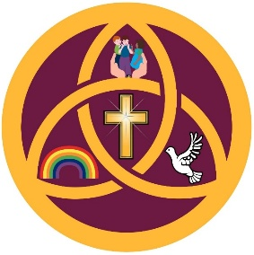
Annual Curriculum Coverage
Reception
Autumn 1
Foundational OAA Skills  (Approximate 3 Weeks) | Fundamental Movement  (Approximate 4 Weeks)
Autumn 2
Dance and Gymnastics
Spring 1
Ball Skills / Net and Wall Foundations
Spring 2
Invasion Games Foundations
Summer 1
Striking and Fielding Foundations
Summer 2
Athletics
KS1
Autumn 1
Foundational OAA Skills  (Approximate 3 Weeks) | Invasion Games  (Approximate 4 Weeks)
Autumn 2
Dance and Gymnastics
Spring 1
Ball Skills / Net and Wall
Spring 2
Invasion Games
Summer 1
Striking and Fielding Games
Summer 2
Athletics

KS2
Autumn 1
Outdoor Adventurous Activities  (Approximate 3 Weeks) | Invasion Games  (Approximate 4 Weeks)
Autumn 2
Dance and Gymnastics
Spring 1
Ball Skills / Net and Wall
Spring 2
Invasion Games
Summer 1
Striking and Fielding Games
Summer 2
Athletics

Swimming
Year 5 pupils receive additional swimming instruction throughout the academic year alongside the core PE curriculum.
Pupils are taught to:
- swim competently, confidently and proficiently over a distance of at least 25 metres
- use a range of strokes effectively
- perform safe self-rescue in different water-based situations

