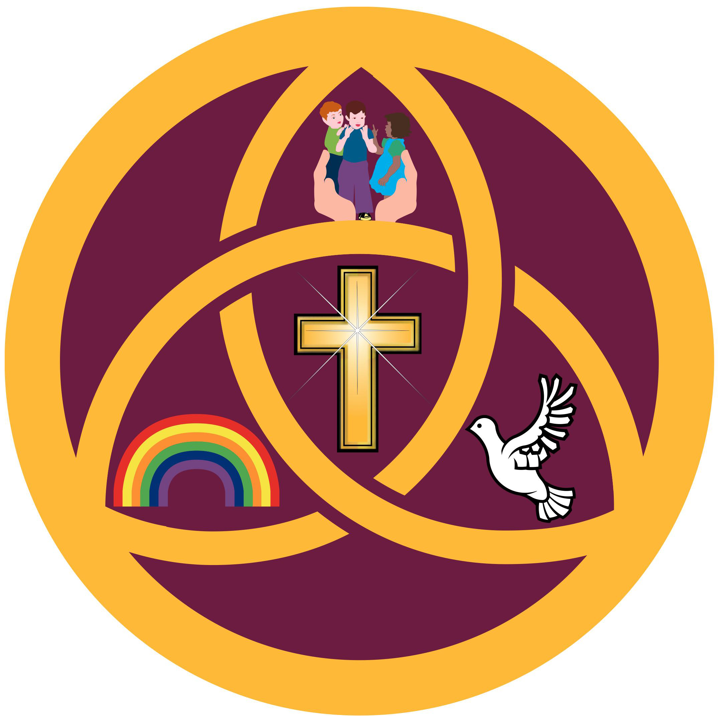

HOLY TRINITY
Church of England Academy

Sports Premium 2017-2018

What is School Sports Premium Grant?
The Sports Premium Grant is additional funding from the Government to improve provision of physical education (PE) and sport in primary schools. It is also for improving the health and wellbeing of primary pupils.

How much is the Sports Premium Grant?
Allocations for the academic year 2017/18 are calculated using the number of pupils in Years 1 to 6 and those age 5 in Reception, as recorded at the January census. At Holy Trinity we will receive £17650.00. The table below shows how we are spending the allocation.

Target area | Cost Details | Potential Impact | Measured Impact
Service Level Agreement with South Tyneside Schools Games | £2311.67 | Pupils to participate in a variety of interschool games, competitions and festivals. Staff CPD. (including Outdoor Education Buyback service) | Increased participation, motivation and enjoyment in sport activities, games and events including interschool competitions across all three key stages.  Developed staff expertise including assessment system that integrates with whole school assessment system Target Tracker.
Affiliation Fees South Tyneside Primary Football Association | £80.00 | KS2Pupils to participate in the FA Snowdon League against other local schools at Temple Park. To develop team spirit and pride through participation in competitions. | Participation in the FA  Snowdon League. Sense of enjoyment, pride and achievement in representing the school. Continued to form links with others schools in the area to organise friendly competitions.
Purchase of PE equipment : | £1036.63 | Develop physical activity at break and lunch times. Ensure pupils have access to quality equipment to develop a range of skills during PE sessions and after school clubs.  Purchase of Swimming hats | Created more  opportunities for KS1 & 2  children to develop  balance, control, spacial  awareness and sense of  enjoyment during play  time and Physical  Education lessons.
Motor Skills Lunch Time Group Key Stage One and Two. (two to three times per week) Identified pupils who need to develop their spatial awareness, perceptual skills, i.e. visual, sequence, hand/eye, foot/eye co-ordination, body balance and memory. | £1105.00 | Pupils will increase their confidence, self-esteem and become aware of their own personal strengths. Pupils will have more opportunities to take part in team games and develop skills that will become not only transferrable to PE but also when playing outside within their peer group. | Pupils who attend the  motor skills group  participated in the KS2  Top Sportsability  Festival. The pupils completed a range of games and events and achieved the silver medal for the overall competition. All of these pupils who attended the festival have received support over the last two to three years for periods of time in our motor development group. The group then went on to represent South Tyneside in a county competition.
Hoops for Health -  Newcastle Eagles Basketball Club in partnership with Eagles Community Foundation | £400.00 | Pupils will have four hours coaching from a qualified level two professional coach based on healthy living themes. Pupils will participate in South Tyneside Hoops4Health Tournament. | The Newcastle Eagle came into school and delivered their Hoops 4 Health program. The children enjoyed learning about healthy eating, goof lifestyle choices and lots of other things which helped us with our science work. We also got to work with some of the actual basketballers, taking part in a range of shooting, catching and dribbling drills and learning how to be part of a team. Finally, we took two teams along to Temple Park Leisure Centre and represented our school in the year five basketball competition narrowly losing in the semi finals!
After School Clubs – Football  Little Dribblers  Boxing  Gymnastics  Rugby  Cheerleading  Dance  Fitness Club  Cross Country | £4928.00 | Provide pupils with opportunities to develop personally, socially and physically through participating in extra- curricular activities in a safe, challenging and enjoyable environment. Enable pupils to take responsibilities for organization and development of their learning. | Children’s skills, abilities and confidence developed. Increased physical activity.  Participated in snowball league cup and other inter-school competitions and events.
Tranquil Treehouse  After School Yoga | £1366.50 | Yoga and Relaxation  Regular exercise is an essential life skill children need to develop in order to stay happy and healthy. Yoga is an ancient form of exercise that focuses on strength, flexibility and breathing to boost physical and mental wellbeing. It is an all-encompassing activity which can stay with the children for many years. Our after school yoga club postures are a series of movements designed to increase strength and flexibility in children. Our yoga is an inclusive, non-competitive activity open to both sexes, all abilities and all ages.  Tranquillity  During our clubs tranquil time, we aim to let children just 'be'. We facilitate the process to allow children to be present, in the here and now, with clear, kind and relaxed minds. Our children's tranquillity practices are techniques that encourage and develop concentration, clarity and self-esteem. They are also a vehicle to calmly see the true nature of things. We practice visualisation which is used at the end of meditation in some of our classes.  Mindfulness meditation  Mindfulness is a form of mediation. It is simply 'awareness' or 'paying attention on purpose'. The main aim of our mindfulness techniques is to help our children calmly acknowledge and accept their feelings, thoughts and bodily sensations. In a rapidly changing modern world, this is a critical skill children need to learn. Used in collaboration with stories, the mindfulness techniques are used to nurture the whole child; physically, mentally and emotionally. | A large proportion of KS1 and 2 children have accessed yoga club.  We have seen an improvement in the core strength of most of the children and the majority are able to hold key yoga poses and positions for a sustained amount of time.  Mindfulness meditation  Mindfulness is a form of mediation. It is simply 'awareness' or 'paying attention on purpose'. The main aim of our mindfulness techniques is to help our children calmly acknowledge and accept their feelings, thoughts and bodily sensations. In a rapidly changing modern world, this is a critical skill children need to learn. Used in collaboration with stories, the mindfulness techniques are used to nurture the whole child; physically, mentally and emotionally.  At first all pupils struggled to settle and listen to the softly spoken words from the mindfulness app.  However this is something that is now requested by most of the pupils as they seem to cherish this quiet time where they can focus on themselves. Mindfulness  has increased the time  that pupils are able to  stay calm and quiet, they  have developed their  breathing techniques  and some of these skills  have been transferred into both the classroom and on the yard.
Sport for Champions athlete visit Laura Samuels | £1272.40 | The children in key stage one and two were asked to raise sponsorship money to take part in a circuit exercise lead by five times British champion triple jumper Laura Samuels. The children received awards from the athlete for raising specific amounts. The children received an ‘inspiring’ assembly from Laura including a demonstration of her sport. | The children raised over two thousand pounds leaving the school with £1271.00 to spend on P.E equipment and resources. They participated in a circuit exercise and listened to an inspiring talk with Laura Samuels as she promoted a positive approach to a healthy lifestyle and determination to succeed to do well.
Attendance at various sporting events in the area, including transport costs. | £1001.90 | Pupils to participate in a variety of interschool games, competitions and festivals. | Increased participation in school games and competitions across all three key stages.
PE Kit Whole School | £265.20 | Various items of PE Kit to allow pupil participation in PE lessons, interschool games, competitions and festivals. | All children are provided with the clothing the need to participate in physical activity and sport, including after school clubs. This has resulted in increased participation for after school clubs when children have needed to borrow equipment.
Carry forward balance | £3667 | We are currently researching outdoor gym equipment and have several quotes to carrying forward towards our funding next year.
Swimming and Water Safety
All schools must provide swimming instruction either in Key Stage 1 or Key Stage 2, in particular, pupils should be taught to:
- swim competently, confidently and proficiently over a distance of at least 25 metres
- use a range of strokes effectively [for example, front crawl, backstroke and breaststroke]
- perform safe self-rescue in different water-based situations.

Holy Trinity Church of England Academy delivers swimming lessons in Key Stage 2 as part of the Year 5 PE curriculum.
Pupils travel by coach from school to Brinkburn Baths for weekly swimming lessons.

The current cohort of 30 Year 6 pupils achieved the following:
- 15 pupils can swim competently, confidently and proficiently over a distance of at least 25 metres
- 15 pupils can use a range of strokes effectively [for example, front crawl, backstroke and breaststroke]
- 15 pupils can perform safe self-rescue in different water-based situations.

